Chapter 13, Solution 53.

Refer to the network in Fig. 13.118.

(a) Find n for maximum power supplied to the 200-Ω load.

(b) Determine the power in the 200-Ω load if n = 10.

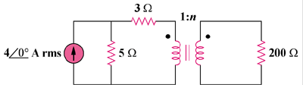

Figure 13.118
For Prob. 13.53.

Solution

(a) The Thevenin equivalent to the left of the transformer is shown below.

8 Ω

+
−

20 V

The reflected load impedance is Z_{L}’ = Z_{L}/n² = 200/n².

For maximum power transfer, 8 = 200/n² produces n = 5.

- If n = 10, Z_{L}’ = 200/10 = 2 and I = 20/(8 + 2) = 2

p = I²Z_{L}’ = (2)²(2) = 8 watts.

